**Lasers had been used in the past:R088, R083BA_2, V1046BA_1**

Attacked points:

* figure out which structure can hold high input power? e.g. number of stages, injector doping concentration, waveguide structures, cavity length
* input current density or input power density could be a good reference.

# Some high power(>200mW)/efficiency laser in record

All data at cw 80K

|  |  |  |  |  |  |  |  |  |  |  |
| --- | --- | --- | --- | --- | --- | --- | --- | --- | --- | --- |
| stage  # | Device | width | length | Jth | ηSlope | λ | **DEQE**  **/stage** | lossi | Power | note |
| um | mm | A/cm2 | W/A | um |  | mW |  |
| **6** | **V1046BA_1H** | **100** | **1.6** | **4.3** | **0.57** | **2.82** | **0.43** | **8.3** | **110@200mA** | **300 mW @ 1A** |
| 6 | V1050BA_1G | 100 | 1.5 |  | 0.5 | 2.8 | **0.377** | 11 | 95@200mA |  |
| 8 | R083BA_1E | 150 | 1.2 | 5.2 | 0.4 | 4.2 | **0.34** | 16 | 250@700mA |  |
| **8** | **R083BA_2G** | **150** | **1.53** |  | **0.3** | **4.2** | **0.25** | **19.6** | **180@700mA** |  |
| 8 | R084BA_1C | 150 | 1.5 |  |  | 4.35 |  |  | 150@500mA |  |
| 8 | R087BA_3G | 150 | 2 | 5 | 0.21 | 5.0 | **0.21** | 18.6 | 120@600mA |  |
| 8 | R088BA_1B | 150 | 1.2 | 5.3 | 0.31 | 4.26 | **0.27** | 22.5 | 230@700mA |  |
| 8 | R088BA_2A | 150 | 0.82 | 6.3 | 0.35 | 4.24 | **0.30** | 28.5 | 250@700mA | power beaming? |
| 10 | R095BA_1B | 150 | 1.15 | 6.55 | 0.6 | 4.1 | **0.40** | 13 | 100@300mA | power rollover at 300mA |
| 10 | R095BA_2A | 150 | 0.82 | 6.3 | **0.7** | 4.14 | **0.47** | 13.7 | 30@50mA | potential to get high power |
| 10 | R096BA_1H | 150 | 1.23 | 10.8 | 0.55 | 4.07 | **0.36** | 14.5 | 300@700mA |  |
| 10 | R097BA_1A | 150 | 1.23 | 30.2 | 0.46 | 4.12 | **0.31** |  | 230@600mA |  |
| 15 | R125BA-1F | 150 | 1.5 | 5.4 | 0.50 | 4.35 | **0.23** |  | 100@200mA |  |
| 15 | R140BA_1F | 100 | 1.5 | 4.6 | 0.6 | 3.95 | **0.26** |  | 50@100mA | other lasers damaged at 200mA |
| 10 | R144BA_1G | 100 | 2 |  | 0.36 | 4.05 | 0.24 | 15.8 | 230@700mA |  |

experimental

theoretical 



so EDQE per stage is the upper limit of the WPE.

# R083BA

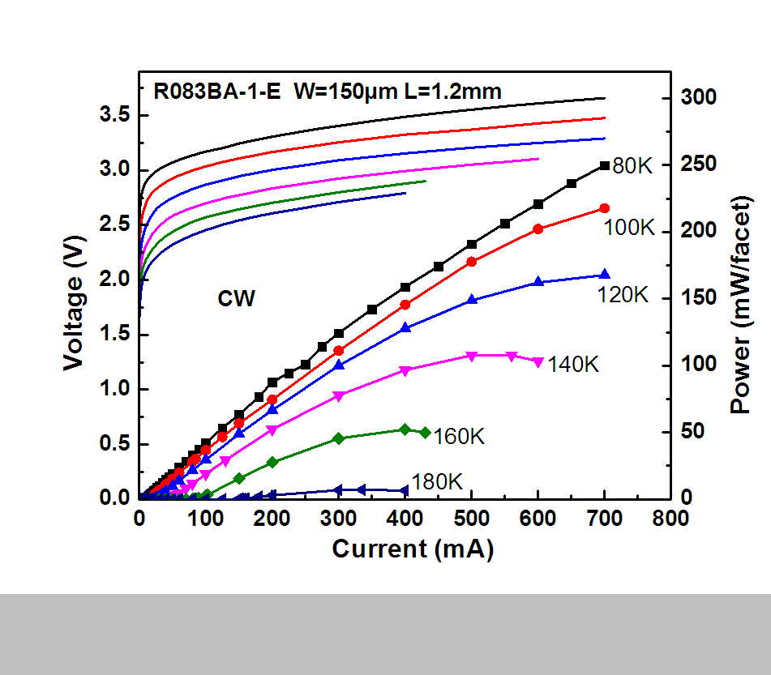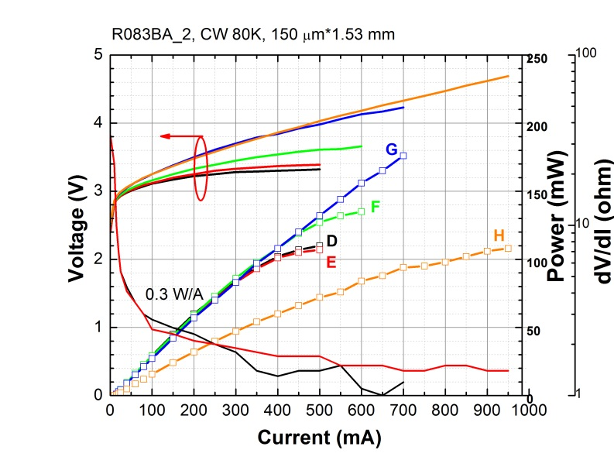

# R088BA

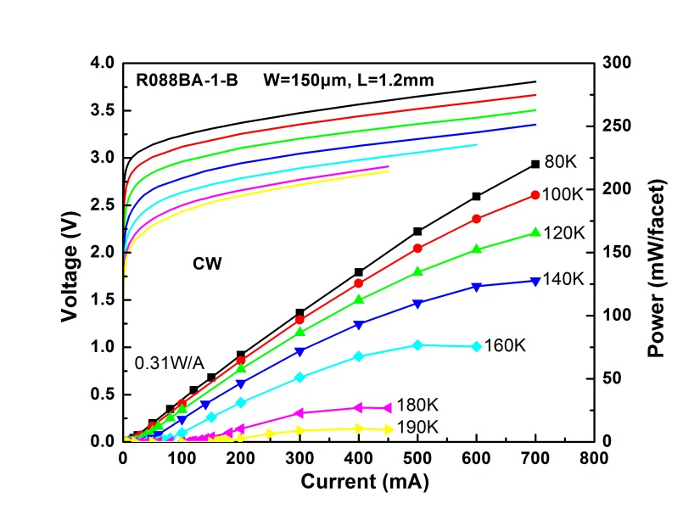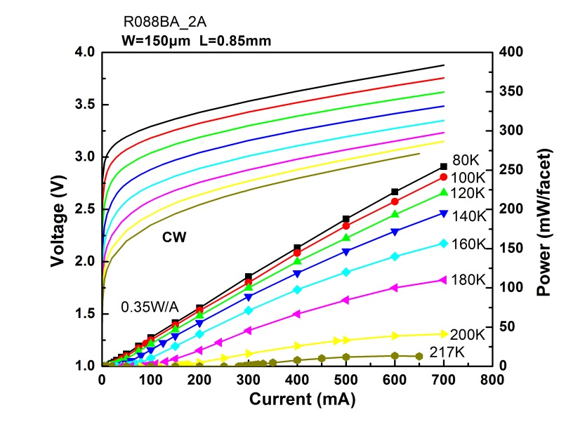

# R096BA

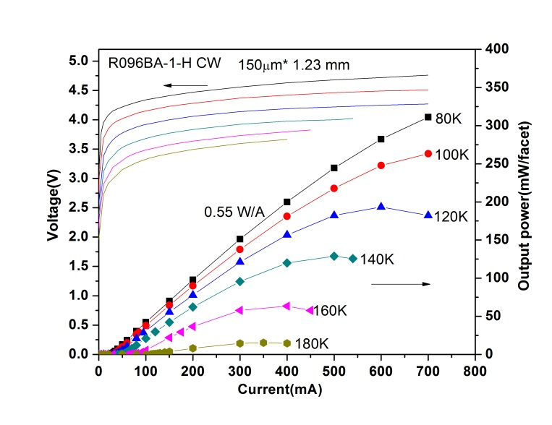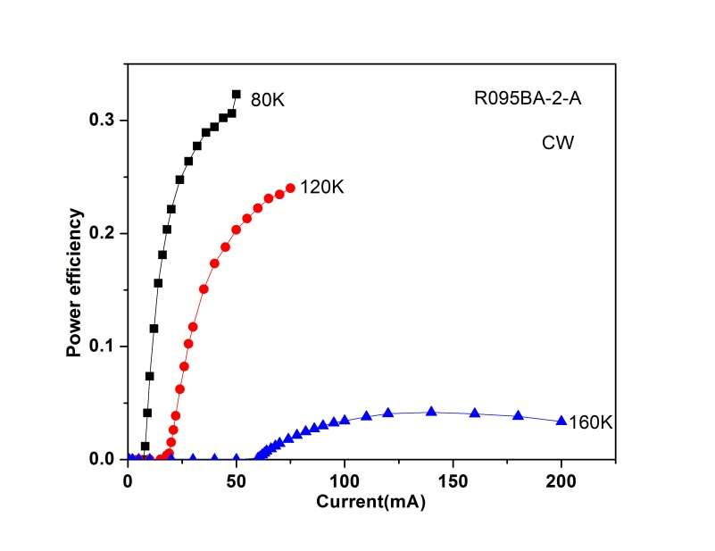

# Type-I

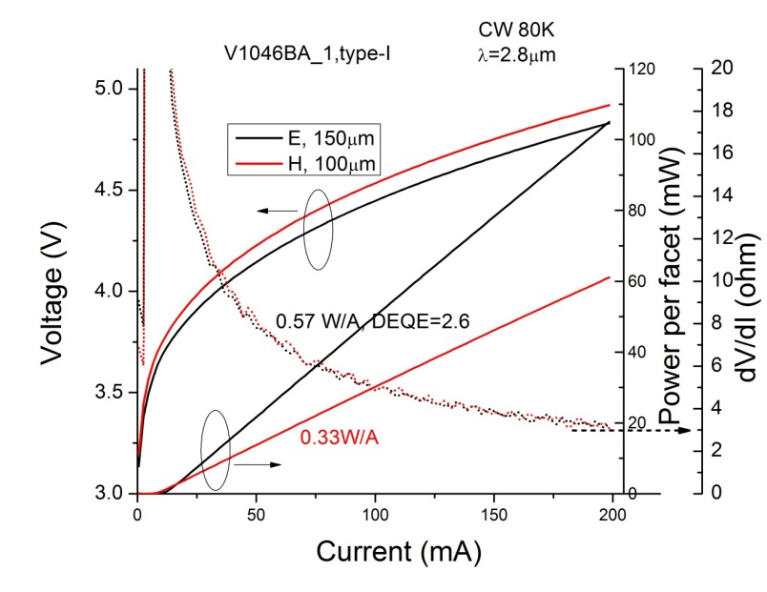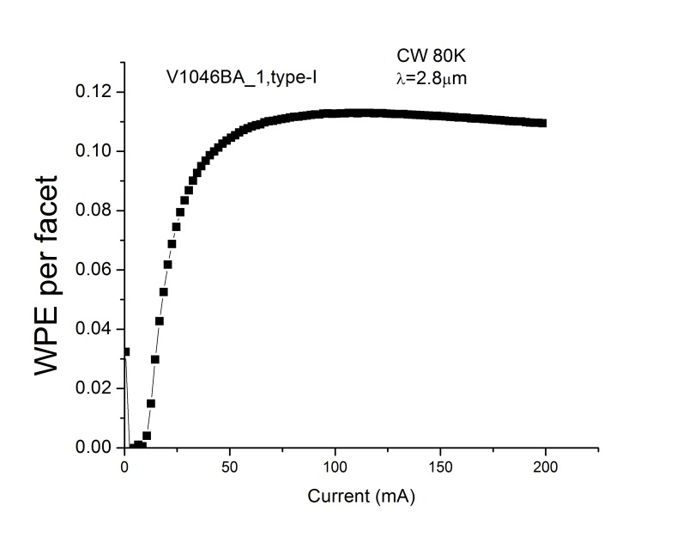

V1050 may be better.

# R125

